English 9a
Herr Biedermeyer
21.02.2001

Name:
Worksheet – Indirect Speech
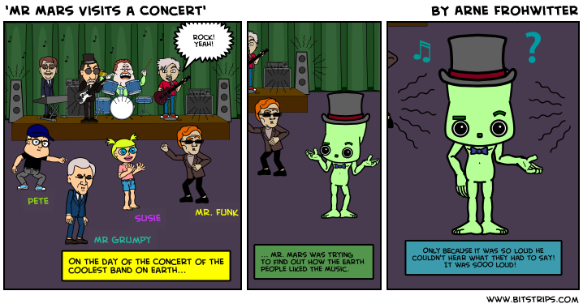
Poor Mr. Mars did not understand a word of what people were trying to tell him and he so wanted to find out what they thought about the music. Can you help him?
We recorded with little microphones what Pete, Susie, Mr. Grumpy and Mr. Funk had to say.
Pete: “Dancing is so great!”
Susie: “I want to buy the CD”!”
Mr. Grumpy: “The music goes on my nerves!”
Mr. Funk: “This is so groovy!”
Task: Write a space-letter (E-Mail) to Mr. Mars telling him what the concert visitors had to say. Put it into reported speech!

