English 11 f
Ms. Fruitboum
24.12.2010

Name:
Worksheet – Medal of Freedom
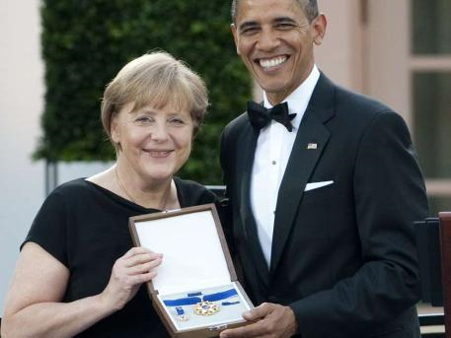
“The Presidential Medal of Freedom […] recognizes those individuals who have made an especially meritorious contribution to the security or national interests of the United States, world peace, cultural or other significant public or private endeavors.”

Task 1: According to Obama, why was Angela Merkel awarded the Medal of Freedom?
Task 2: Read the additional text about the Presidential Medal of Freedom. In your own words describe what the Medal stands for.
Task 3: Get together in groups of four and discuss the following questions: Who else has been awarded the Medal? Compare their merits to those of Angela Merkel. Do you think she deserves this honor? Be prepared to present your results in class.

